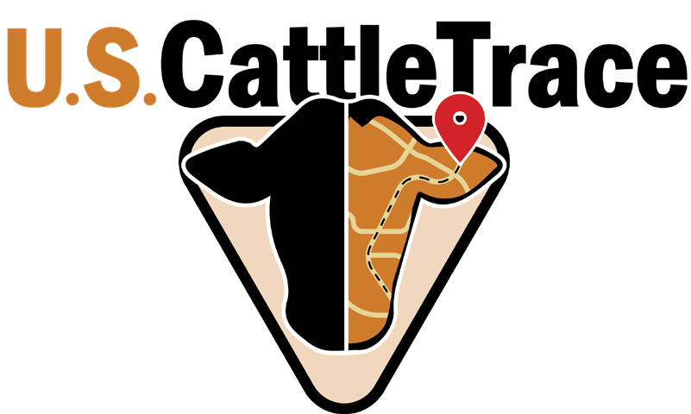PO Box 23

Wamego, KS 66547

785-821-1082

U.S. CattleTrace Internship Application-

Name-

Email-

Street Address-

City, State, Zip Code-

Phone Number-

Current College or University Attending-

Current Major-

Reference Name-

Reference Email Address-

Relationship to Reference-

Describe your background in the agricultural industry (Max 300 words) -

What aspect of animal disease traceability would you like to learn about during your internship if selected?